

Website application for Learning website
Senior Project
By

Ghadeer khalaf

Submitted to the School of Arts & Science of the
Lebanese International University Beqaa, Lebanon

In part of fulfillment of the requirements for the degree of
BACHERLOR OF SCIENCE IN
COMPUTER SCIENCE AND INFORMATION TECHNOLOGY

Supervised by: Dr. Haissam El-Aawar
Spring 2024-2025

Dedication:
For everyone who supported us, to my family, whose constant support and unconditional love have been the foundation of my journey through university life. To my parents, especially my mother, who cared for me through the long nights and endless challenges, always encouraging me to strive for excellence. I also dedicate this work to my instructors, who taught me that true knowledge is not just about passing exams, but about a lifelong passion for learning and growth. Without their guidance and inspiration, this achievement would not have been possible.

Abstract
This project focuses on the development of a comprehensive institutional website designed to streamline and manage the academic interactions between students, teachers, and administrators. The website features three main user roles: Student, Teacher, and Admin, each with dedicated and role-specific functionalities.
On the Student Page, school students are able to register and log in securely to the platform. After successful authentication, students can browse through a list of available majors and corresponding courses offered by the institution. Students can then enrol in the major or courses of their choice in preparation for university education, ensuring an organized and goal-oriented academic progression.
The Teacher Page allows educators to participate in the institution’s teaching activities. Teachers can register and submit their Curriculum Vitae (CV) through the portal. However, access to teaching responsibilities is gated through an approval process: submitted CVs are reviewed by the administrator. Only upon administrative approval is a teacher granted full access to interact with the platform and contribute to the learning process by teaching assigned courses.
The Admin Page plays a critical role in maintaining and overseeing the website's operations. The administrator is empowered with full control to manage courses by adding new ones or updating existing ones. The admin can also manage the student body by adding, editing, or deleting student accounts as necessary. Similarly, the administrator oversees teacher applications, approving qualified applicants and managing the overall roster of teaching staff to ensure that only vetted educators are involved in the academic programs.
Overall, this project creates a seamless digital environment that enhances institutional management by automating key processes related to student enrolment, teacher recruitment, and course administration. By centralizing these activities within a user-friendly online platform, the institution ensures efficiency, transparency, and a structured pathway for academic success.

Table of Contents:
Dedication……….................................................................................................... II
Acknowledgments.................................................................................................. III
Abstract.................................................................................................................. IV
List of Figures......................................................................................................... V
List of Tables .........................................................................................................VI
Chapter 1: ...............................................................................................................10
Project General Context...........................................................................................10
  - Introduction.........................................................................................11
  - Objectives............................................................................................12
  - Scope...................................................................................................13
  - Project Software..................................................................................14
  - Problematic.........................................................................................16
  - Optimization........................................................................................18

Chapter 2: .............................................................................................................. 19

Software Requirements and System Analysis: ..................................................... 19
2.1 Functional & Non-Functional Requirements: ................................................. 20
2.1.1 Functional Requirements: ............................................................................. 20
2.1.2 Non-Functional Requirements: ..................................................................... 21
2.2 Use Case Diagram & Scenario: ....................................................................... 23
2.2.1 Use case Diagram: ........................................................................................ 24
2.2.2 Use case Scenario: ........................................................................................ 25

Chapter 3: ...............................................................................................................35
System Design.........................................................................................................35
3.1 Class Diagram ........................................................................................36
3.2 ER Diagram………………………........................................................37

Chapter 4:

Technical Specifications and Implementations.......................................................25
4.1 Introduction.............................................................................................27
4.2 Application Platforms.............................................................................27
4.2.1 Cloud Services...........................................................................27
4.2.2 Data Services..............................................................................28
4.2.3 Application Services..................................................................29
4.3 Web Services..........................................................................................30
4.4 Chosen Platforms....................................................................................30
4.4.1 Visual Studio.............................................................................31
4.4.2 PhpMyAdmin............................................................................31
4.4.3 cPanel........................................................................................32
4.5 Technical Tools......................................................................................33
4.5.1 Application Interface.................................................................33
4.5.2 Web Application Interfaces......................................................34
4.5.2.1 Index Page..............................................................................35
4.5.2.2 Home Page..............................................................................36
4.5.2.3 Menu.......................................................................................37
4.5.2.4 Add New Guest.......................................................................38
4.5.2.5 All guest Information..............................................................39
4.5.2.6 Attendance..............................................................................40
4.5.2.7 Bills ............ ..........................................................................41
4.5.2.8 Add New Bill Type. ...............................................................42
4.5.2.9 Confirm Bills...........................................................................43
4.5.2.10 Take attendance.....................................................................44
4.5.2.11 Add New Admin...................................................................45

List of Figures:
Figure 2.2.1 Use case diagram .......................................................................................24
Figure 3.1 Class diagram...............................................................................................37
Figure 3.2 ER Diagram.................................................................................................38

List of Tables

Table 1- Registration use case…...................................................................................................26
Table 2- Login use case -------.....................................................................................................27
Table 3- Course Enrolment use case ...................................................................................28
Table 4- View Course enrolment use case ............................................................................29
Table 5- CV submission use case......................................................................................30
Table 6- Teacher managing assigned courses use case .............................................................31
Table 7- Teacher course Acceptance use case........................................................................32
Table 8- Admin managing of student use case.......................................................................33
Table 9- Admin managing of teachers use case......................................................................34
Table 10- Admin managing of courses use case......................................................................35

Chapter 1:
Project general context

In this chapter I will present an overview of the project, including its purpose, goals, and scope. It introduces the software used, the main problem the system addresses, and possible optimizations. This chapter sets the foundation for understanding the learning website and its development context.

1.1 Introduction:
This website is a comprehensive web-based system designed for managing an educational institution, offering distinct functionalities for students, teachers, and administrators. The primary goal of this platform is to streamline the registration, course management, and teacher recruitment processes in a university or educational institute setting.
The system is divided into three main modules, each tailored to the needs of its specific user type:
- Student Module:
Students can register for the website and log in to their dedicated portal. After logging in, students can browse available courses and enrol in major-specific courses they are interested in. This feature ensures a guided and organized course selection process based on academic interests.
- Teacher Module:
Teachers can access their dedicated portal to submit their Curriculum Vitae (CV) and basic information such as their major, username, and email. Once submitted, the CsV is reviewed by the administrator. Only after receiving approval from the admin will the teacher gain access to teaching functionalities and the ability to manage their courses.
- Admin Module:
The admin has full control over the platform. Admin responsibilities include:
  - Adding, updating, or deleting courses.
  - Managing student accounts (e.g., adding or deleting students).
  - Reviewing and approving teacher CV submissions.
  - Managing teacher accounts and assigning them to courses.
This website provides a secure login system with role-based redirection to ensure that users only access the features relevant to their role. It is designed to support smooth communication between students, teachers, and administrators, helping educational institutions maintain a modern, efficient, and organized workflow.

1.2 Objectives:
The primary objectives of this website are to simplify and digitalize the management of academic activities within an educational institution. This platform aims to serve students, teachers, and administrators through clearly defined roles and functionalities. The specific objectives of the system are as follows:
- Facilitate Student Course Enrolment:
Allow school students to log in to the system and register for university-level major courses based on their academic interests.
- Streamline Teacher Recruitment and Management:
Enable teachers to submit their CVs online for review. After approval by the administrator, the system grants access to teaching features and course management tools.
- Centralize Administrative Control:
Provide administrators with full control over the system, including the ability to:
  - Add, update, or delete course offerings.
  - Manage student records (enrolment, deletion).
  - Manage teacher records (approval, deletion, and assignment).
- Ensure Role-Based Access and Security:
Implement secure login and role-based access control to ensure that users only access the features relevant to their roles (student, teacher, or admin).
- Improve Operational Efficiency:
Reduce manual work and paperwork by offering an automated and user-friendly interface for all stakeholders in the institution.
- Support Institutional Growth:
Provide a scalable solution that can grow with the institution's needs, making it easy to expand course offerings and manage more users over time.

1.3 Scope:
This documentation outlines the scope of a web-based institute management system that caters to three types of users: students, teachers, and administrators. The system is designed to manage course registration, teacher recruitment, and administrative operations in a streamlined and efficient manner.
The scope of this project includes:
- Student Interface:
  - Student registration and login.
  - Viewing available university major courses.
  - Enrolling in selected major courses after login.
- Teacher Interface:
  - Teacher registration and login.
  - Uploading CVs and academic details for review.
  - Access to the system only after approval from the administrator.
- Admin Interface:
  - Secure login and access to the admin dashboard.
  - Managing (adding/deleting) student and teacher accounts.
  - Reviewing and approving teacher CV submissions.
  - Creating and managing available courses.

In-Scope Features:
- Role-based login and redirection (student, teacher, admin).
- Form submissions for student course enrollment and teacher CV upload.
- Database storage of users, courses, and CVs.
- Admin control over users and course offerings.

Out-of-Scope Features (Future Enhancements):
- Online payment for course registration.
- Automated grading or learning management features.
- Messaging or communication tools between users.
- Mobile application support.

1.4 Project Software:
This section lists the software tools, frameworks, and technologies used in the development and deployment of the Institute Management System. These tools are essential for building, testing, and running the platform efficiently.

1. Frontend Technologies
- HTML – Used for structuring the web pages.
- CSS – Used for styling and layout to provide a responsive and user-friendly interface.
- JavaScript – Used for enhancing interactivity on the frontend (e.g., form validation, dynamic UI components).

2. Backend Technologies
- PHP – The server-side scripting language used to handle form submissions, database operations, and user authentication.
- MySQL – The relational database management system used to store user data, course information, and teacher CVs.

3. Web Server
- Apache HTTP Server – Used for hosting the PHP files and managing HTTP requests.

4. Database Management Tools
- phpMyAdmin – A web-based interface to manage the MySQL database easily (optional, but recommended for development).

5. Development Tools
- VS Code – Recommended code editors for writing and editing PHP, HTML, CSS, and JavaScript code.

- WAMP– Local development environments that bundle Apache, MySQL, and PHP to test the application before deployment.

6. Browser Support
- Fully compatible with all modern web browsers, including:
  - Google Chrome
  - Mozilla Firefox
  - Microsoft Edge
  - Safari

7. Operating System Compatibility
- Development & Deployment:
  - Windows, Linux (Ubuntu/CentOS), or macOS
- Client Access:
  - Any operating system with a modern web browser

1.5 Problematic:
Managing educational institutions manually often leads to several inefficiencies, including poor communication, difficulty in managing course enrollments, and delays in processing teacher applications. Traditional systems typically rely on paperwork or disconnected tools that result in a lack of centralization and automation. This can cause confusion among students, slow recruitment processes for teachers, and administrative overload.

Identified Problems:
- Manual Course Enrollment:
Students face challenges in enrolling in their preferred university major courses due to the absence of an organized, online platform.
- Inefficient Teacher Recruitment:
Teachers have no structured system to submit their qualifications or CVs for teaching roles, and administrators lack a proper review and approval workflow.
- Disorganized Data Management:
Information about courses, students, and teachers is not stored or accessed efficiently, increasing the chances of errors, duplication, and data loss.
- Administrative Overload:
Without automation, administrators must handle repetitive tasks such as user management and course updates manually, consuming time and resources.
- Lack of User Role Separation:
Existing systems (if any) do not clearly separate functionalities for students, teachers, and administrators, which can lead to security and usability issues.

Goal:
To solve these problems, a centralized and web-based system is required that offers:
- An online portal for student course registration.
- A streamlined process for teacher CV submission and approval.
- Complete administrative control over user and course management.
- Secure, role-based access for all types of users.

1.6 Optimization:
To ensure that the Institute Management System operates efficiently, securely, and reliably, several optimization strategies have been applied throughout the design and development of the project. These optimizations aim to enhance performance, user experience, and system scalability.

1. Database Optimization
- Efficient Table Design: Tables are normalized to avoid redundancy and ensure data integrity.
- Indexes: Applied to frequently queried fields (e.g., user roles, course IDs) to speed up searches and data retrieval.
- Foreign Key Constraints: Used to maintain relationships between students, teachers, courses, and admin data.

2. Code Optimization
- Modular PHP Code: Reusable functions and modules are used to minimize code duplication and improve maintainability.
- Input Validation: All form inputs are sanitized to prevent SQL injection and ensure security.
- Efficient Queries: Optimized SQL queries are used to reduce load time and improve response speed.

3. Performance Optimization
- Minified CSS and JavaScript: Front-end files are compressed to improve page load speed.
- Lazy Loading: Used for optional media (e.g., teacher CV previews) to improve loading time for content-heavy pages.
- Caching Techniques (Optional): Can be implemented for frequently accessed data like course listings.

4. Security Optimization
- Role-Based Access Control (RBAC): Ensures that students, teachers, and admins can only access features assigned to their roles.
- Password Hashing: User passwords are encrypted using strong hashing algorithms (e.g., bcrypt) for secure storage.
- Session Management: Secure session handling to protect against unauthorized access and session hijacking.

5. User Experience (UX) Optimization
- Responsive Design: Interface adapts to different screen sizes and devices (mobile, tablet, desktop).
- Clear Navigation: Organized menus and buttons to make the platform intuitive and easy to use for all user types.
- Real-Time Feedback: Alert messages and confirmations to guide users during interactions (e.g., form submission success/failure).

6. Scalability Considerations
- The system is designed to support future expansion, such as:
  - More student and teacher registrations.
  - Additional course categories.
  - Integration of new modules like messaging, analytics, or e-learning.

Chapter 2:
Functional and Conceptual
Study

In this Chapter I will provides a detailed analysis of the software requirements for the system, including both functional and non-functional requirements, as well as an exploration of the use case diagram and associated scenarios.

2.1 Functional & Non-Functional Requirements:

2.1.1Functional Requirements:
Functional requirements define the specific behavior and functions the system must perform. These requirements are based on user roles and describe how the system responds to inputs and handles data.

1. User Authentication
- The system must allow students, teachers, and administrators to register and log in with their credentials.
- The system must redirect users to their respective dashboards after login.

2. Student Functions
- Students must be able to register for an account.
- Students must be able to view all available university major courses.
- Students must be able to enroll in selected major courses.
- Students must be able to view the status of their enrollment.

3. Teacher Functions
- Teachers must be able to register and log in to the system.
- Teachers must be able to upload their CV and select their major.
- Teachers must not access course functions until approved by the admin.

4. Admin Functions
- Admin must be able to log in securely to the admin panel.
- Admin must be able to add, update, and delete courses.
- Admin must be able to view submitted teacher CVs and approve or reject them.
- Admin must be able to add or remove students and teachers from the system.

5. Database Management
- The system must store user data (students, teachers, admins), course information, and CV uploads securely in a MySQL database.

2.2.2 Non-Functional Requirements:
Non-functional requirements define how the system should operate rather than what it should do. These include performance, usability, security, and scalability aspects.

1. Performance
- The system should respond to user actions within 2 seconds under normal load.
- The system should be able to handle up to 100 simultaneous users without performance degradation.

2. Security
- Passwords must be stored using a secure hashing algorithm (e.g., bcrypt).
- All input fields must be validated and sanitized to prevent SQL injection.
- User sessions must be securely managed and time out after inactivity.

3. Usability
- The system must provide a clear and intuitive user interface for all user types.
- Navigation must be simple and accessible from any standard browser.
- All forms must provide real-time feedback (e.g., success, error messages).

4. Scalability
- The system should be designed to support future expansion (e.g., more users, courses, features).
- The database structure should allow easy addition of new modules.

5. Compatibility
- The system must work on all major modern web browsers (Chrome, Firefox, Edge, Safari).
- The platform should be responsive and mobile-friendly.

6. Availability
- The system should maintain 99% uptime under normal hosting conditions.
- Backups of the database should be performed regularly (manually or automated).

2.2 Use Case Diagram & Scenario:

2.2.1 Use Case Diagram:

The use case diagram provides a visual representation of how different types of users interact with the learning website system. It identifies four primary actors: students, teachers, admins, and visitors, each with specific roles and functionalities. Students are able to register, log in, browse available courses, enroll or unenroll in selected courses, and send messages through a contact form. Teachers can register and log in, upload their CVs for approval, and upon acceptance by the admin, they gain access to view courses, teach assigned subjects, and manage course materials. Teachers can also send messages within the system. Admins play a central role in managing the platform by adding, updating, and deleting courses, handling student and teacher accounts, and approving or rejecting teacher CV submissions. Additionally, the system allows unregistered visitors to browse the site and submit messages. This diagram outlines the main functionalities of the system and clearly defines the boundaries and responsibilities of each user role within the application.

Figure 2.2.1 Use case diagram
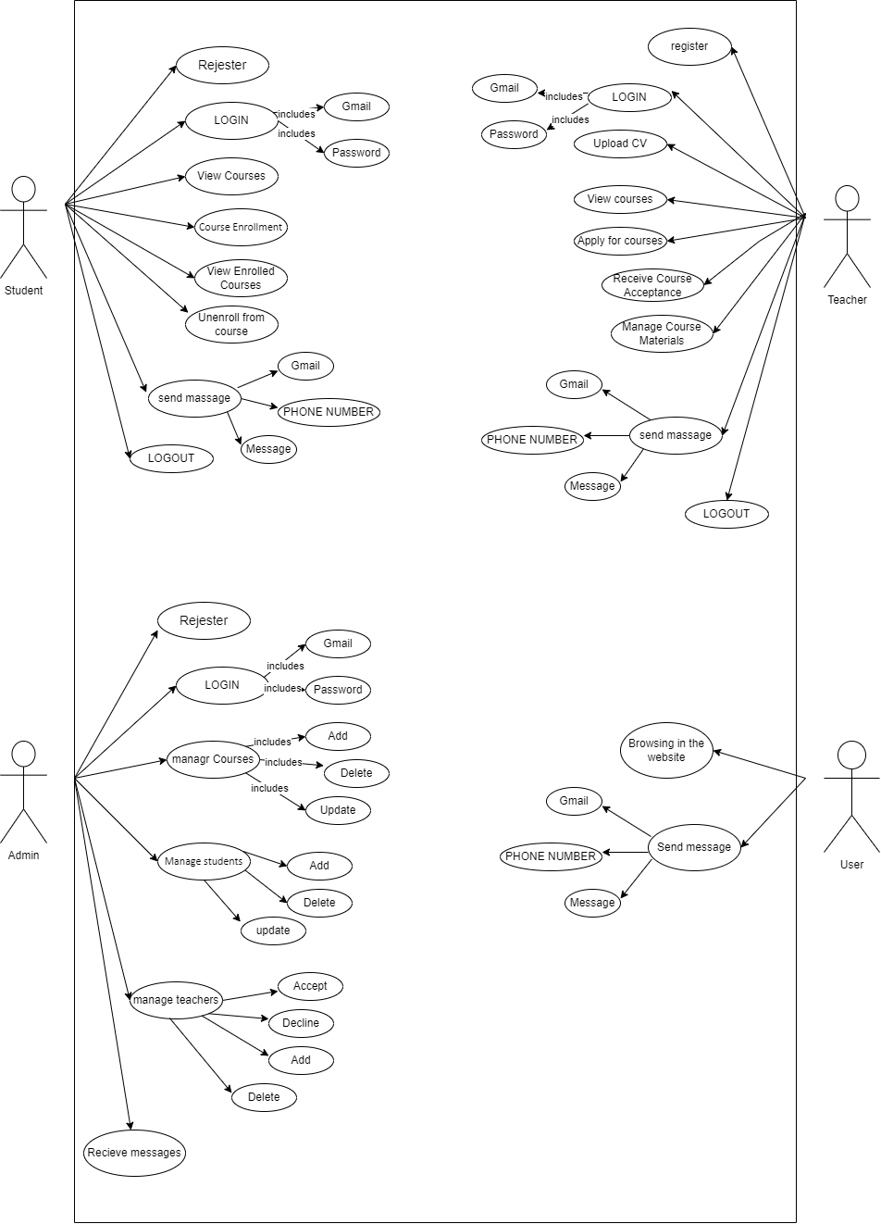

2.2.2 Use case Scenario:
In this part we will explain all the mentioned use cases of student, teacher, and admin in details, regarding primary actors, main flow, and the alternative one, in addition to the short description for each use case.
Table 1- Registration use case
Use case-Name: | Student and teacher registration
Use case-ID: | MCS-1
Priority: | High
Primary actor: | Student, Teacher
Description: | To allow students and teachers to register by creating an account on the institute’s website, providing the required information to redirect to the login page.
Basic Flow: | 1. The user (either Student or Teacher) clicks on the "Register" button on the website's homepage.  2. System displays registration form  3. The user (Student/Teacher) fills out the form and clicks the "Submit" button.  4. The system verifies if all information fields are filled out correctly.  5. System confirms registration success.  6. System redirects to login page.
Alternative Flow: | 1. Invalid Email or Duplicate Account.  2.Incomplete Form.  3. Weak Password
Precondition: | • The user must not have an existing account in the system.  • The registration form is accessible from the homepage.
Post-condition: | • A new account is created for the Student or Teacher.  •The user is redirected to the login page, ready to log in to the system.

Table 2- Login use case
Use case-Name: | User Login (Student, Teacher, and Admin)
Use case-ID: | MCS-1
Priority: | High
Primary actor: | Student, Teacher, Admin
Description: | To authenticate students, teachers, and admin users based on their login credentials and redirect them to their respective dashboards or home pages according to their accounts.
Basic Flow: | 1. The user (student, teacher, or admin) navigates to the login page of the institute’s website.  2The user fills in the required fields and submits the login form by clicking the "Login" button.  3. The system checks the provided email/username and password against the stored user database.  4. After successful authentication, the system determines the user’s account (Student, Teacher, or Admin) based on their account information.  5. Based on the user’s information, the system redirects them to their specific pages.
Alternative Flow: | 1. Incorrect Credentials (Email or password).  2. Account Not Verified (New Users).  3. Forgotten Password
Precondition: | • The user (student, teacher, or admin) must have successfully registered in the system and verified their email.  • The system must be operational and accepting login requests.  •The user must have a valid username/email and password.
Post-condition: | • The user is successfully authenticated and redirected to their respective dashboard (Student, Teacher, or Admin).
Table 3- Course Enrolment use case

Use case-Name: | Course Enrolment
Use case-ID: | MCS-1
Priority: | High
Primary actor: | Student
Description: | The course enrolment use case is to allow students to browse available courses and enrol in the courses they wish to take for the semester or academic period.
Basic Flow: | 1. The student navigates to the website’s login page and enters their credentials (email and password).  2. Student Navigates to Course enrolment Section.  3. System Displays Available Courses.  4. Student Selects Course(s) to Enrol.  5. Student Confirms Enrolment.  6. System Confirms enrolment.
Alternative Flow: | 1. Prerequisites Not met (incorrect email or password).  2Course Full (enrolment Failed).
Precondition: | • The student must be registered and logged into the system.  • Courses must be available for enrolment
Post-condition: | • The student is successfully enrolled in the selected course(s) and receives a confirmation.

Table 4- View Course enrolment use case

Use case-Name: | View Course enrolment
Use case-ID: | MCS-1
Priority: | High
Primary actor: | Student
Description: | The view course enrolment use case to allow students to view the courses they have enrolled in, along with relevant details such as course schedule, materials, and enrolment status.
Basic Flow: | 1. Student logs into the system  2. Student accesses the course section 3. System shows course details (Course name and code, Teacher's name, Course schedule (start date, end date), Course materials).
Alternative Flow: | 1. No Courses Enrolled
Precondition: | • The student must be registered and logged into the system.  • The student has successfully enrolled in one or more courses.
Post-condition: | • The student successfully views the courses in which they are enrolled.  • The student can access course materials, view deadlines, and track their progress in each course.

Table 5- CV submission use case

Use case-Name: | CV submission
Use case-ID: | MCS-2
Priority: | High
Primary actor: | Teacher
Description: | The CV submission use case to allow teachers to submit their CVs (Curriculum Vitae) to the system for review and approval by the admin, enabling them to be considered for teaching positions in the institute.
Basic Flow: | 1. Teacher Logs In.  2. Teacher Accesses CV Submission Page.  3. Teacher Uploads CV.  4. Teacher Submits CV.  5. System Confirms CV Submission.
Alternative Flow: | 1. Missing or Incorrect Information  2. Invalid File Format or Size.
Precondition: | • The teacher must have registered and created an account in the system.  •The teacher must be logged in.  • The teacher must submit their CV and wait admin approval before teaching courses.
Post-condition: | • The Teacher is approved, can teach assigned courses, and manage course content.

Table 6- Teacher managing assigned courses use case
Use case-Name: | Teacher Managing Assigned Courses
Use case-ID: | MCS-3
Priority: | High
Primary actor: | Teacher
Description: | After being approved by the admin, the teacher logs into the system and manages the courses they are assigned to. The teacher can upload course materials, schedule sessions, and communicate with students. The teacher can also update the course details within the scope allowed by the admin.
Basic Flow: | 1. The teacher navigates to the login page and enters valid credentials (username and password).  2. The system verifies the teacher's credentials and grants access to the teacher dashboard.  3. The system shows a list of all courses assigned to the teacher.  4.The student selects a course they want to enroll in  5. The teacher can update various aspects of the course, such as: Course materials, course schedule.  6. The teacher can view the list of students enrolled in the course, along with their progress, submissions, and grades.
Alternative Flow: | 1. Invalid Teacher Credentials  2. No Courses Assigned to Teacher  3. The teacher tries to modify the content of a course that is also managed by other teachers (e.g., collaborative courses with multiple instructors).
Precondition: | • The teacher must be approved by the admin.  • Courses must be assigned to the teacher.
Post-condition: | • The teacher can manage the content and sessions for the assigned courses.
Table 7- Teacher course Acceptance use case
Use case-Name: | Teacher Course Acceptance
Use case-ID: | MCS-3
Priority: | High
Primary actor: | Teacher
Description: | The teacher course acceptance use case is to allow the teacher to accept or decline a course assigned by the admin, enabling the teacher to manage the course if accepted.
Basic Flow: | 1. After reviewing the teacher’s CV and qualifications, the admin assigns a course to the teacher.  2. The Teacher logs into the system using their credentials (email and password).  3. The teacher navigates to the "My Courses" section of the website.  4. The assigned course is displayed in the list of courses, along with relevant information (e.g., student list, course materials, schedule).  5. The system provides an option for the teacher to either Accept or Decline the course.
Alternative Flow: | 1. Teacher Declines the Course  2. Teacher Receives Multiple Course Assignments
Precondition: | • The teacher must have submitted their CV and been registered on the system.  • The teacher is awaiting approval from the admin to be assigned to a course.
Post-condition: | •The teacher has successfully accepted the assigned course.  •The teacher can now manage the course, interact with students, and upload necessary materials.

Table 8- Admin managing of student use case

Use case-Name: | Admin management of students
Use case-ID: | MCS-4
Priority: | High
Primary actor: | Admin
Description: | The admin logs into the dashboard and navigates to the student management section. The admin can view the list of all students enrolled. The admin can add a new student, update students, or delete students.
Basic Flow: | 1.The admin navigates to the login page and enter username and password.  2.The system verify the admin credentials.  3.The admin select the ‘manage students’ option from the dashboard.  4. The system displays a list of all registered students  5. The admin can choose to update the student’s details (e.g., change enrolled courses, update contact information) or delete the student from the system.  6. The admin can also choose to add a new student manually by clicking the “Add New Student” button.
Alternative Flow: | 1. The system detects invalid admin credentials (incorrect username or password).  2. The system displays a message: “No students found” if there are no registered students in the system.  3. The admin tries to add a new student, but the system detects that a student with the same email or identifying information already exists. The system displays an error message: “A student with this email already exists.”
Precondition: | •The admin must be logged in.  •Students must be enrolled in the system.
Post-condition: | •The admin can view, update, or delete student records as needed.

Table 9- Admin managing of teachers use case

Use case-Name: | Admin management of teachers
Use case-ID: | MCS-5
Priority: | High
Primary actor: | Admin
Description: | The admin accesses the teacher management section of the website and reviews teacher profiles. For each teacher, the admin can approve, reject, or remove their access to the system. Once approved, the teacher can begin offering courses. If necessary, the admin can also manage the list of teachers, editing or deleting profiles.
Basic Flow: | 1.The admin navigates to the login page and enter username and password.  2.The system verify the admin credentials.  3.The admin select the ‘manage teachers’ option from the dashboard.  4. The system displays a list of all registered teachers, along with their profiles, CVs, and current status (e.g., pending, approved, rejected).  5. The admin can choose Admin Approves, Rejects, or Removes the Teachers.  6. The admin can also choose to add a new teacher manually by clicking the “Add New teacher” button.
Alternative Flow: | 1. The system detects invalid admin credentials (incorrect username or password).  2. If there are no teachers registered in the system, the system displays a message: “No teachers found.”  3. The admin tries to add a new teacher, but the system detects that a teacher with the same email or identifying information already exists.
Precondition: | • The teacher must submit their CV for review.  • The admin must be logged in.
Post-condition: | • The admin can approve or reject teacher applications and manage their profiles.

Table 10- Admin managing of courses use case

Use case-Name: | Admin Course management
Use case-ID: | MCS-6
Priority: | High
Primary actor: | Admin
Description: | The admin is responsible for adding and managing the available courses. The admin logs into the system, creates new courses, assigns instructors, and sets the course details (e.g., course name, description, duration). The admin can also edit existing courses or remove them from the system if necessary.
Basic Flow: | 1.The admin navigates to the login page and enter username and password.  2.The system verify the admin credentials.  3.The admin select the ‘manage courses’ option from the dashboard.  4. The system shows a list of all available courses, including relevant details such as course name, description, teacher assigned, and status.  5. The admin edits the course details, such as: Course name, Course description, Duration, assigned teacher, Course capacity  6. The admin can add a new course by selecting the “Add Course” option and entering all the necessary course details, including assigning a teacher.
Alternative Flow: | 1. The system detects invalid admin credentials (incorrect username or password).  2. The system displays a message: “No courses available” if there are no courses currently in the system.  3. The admin tries to add a new course, but the system detects that a course with the same name or similar details already exists in the system.
Precondition: | •The admin must be logged in.  •Teachers must be available to be assigned to courses.
Post-condition: | • Courses are added, edited, or deleted as per the admin’s actions. Students and teachers can see the updated course catalog.

Chapter 3:
System Design

In this chapter, I will focus on the system design phase, presenting key design diagrams such as the Class Diagram and the Entity-Relationship (ER) Diagram to illustrate the system’s structure and data relationships.

Class Diagram:
This class diagram represents the structure of an online learning system by defining its main classes, their attributes, methods, and the relationships between students, teachers, admins, courses, and learning materials.
Figure 3.1 Class diagram
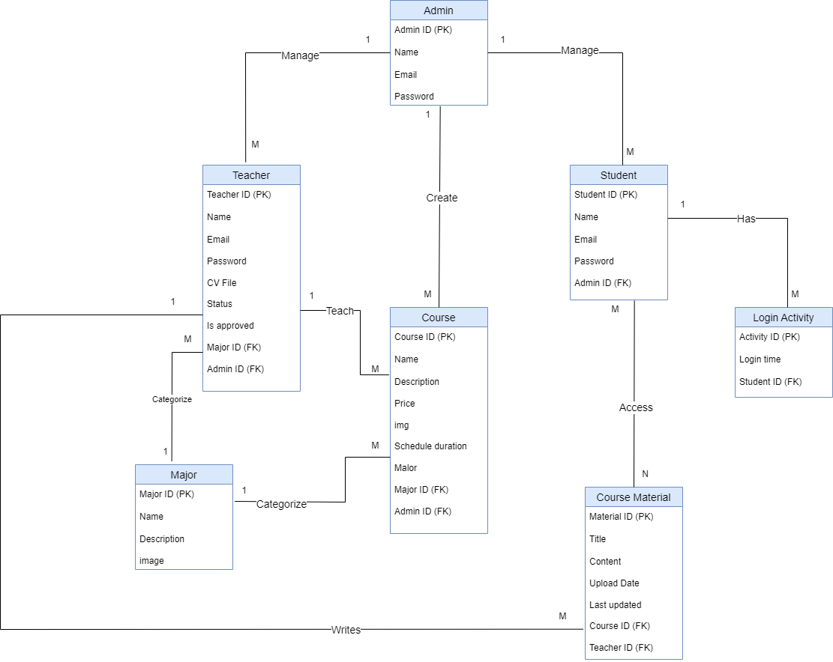
ER-Diagram:
This ER diagram represents an online learning system where admins manage teachers and courses, teachers create course materials, and students register for courses and access materials. Majors categorize both teachers and courses, while student activity is tracked through login records.
Figure 3.2 ER Diagram


